**TASK 1: Database Design (Normalisation):**

1. **Create the database named "HMBank"**

**QUERY:** CREATE DATABASE HMBank;

USE HMBank;

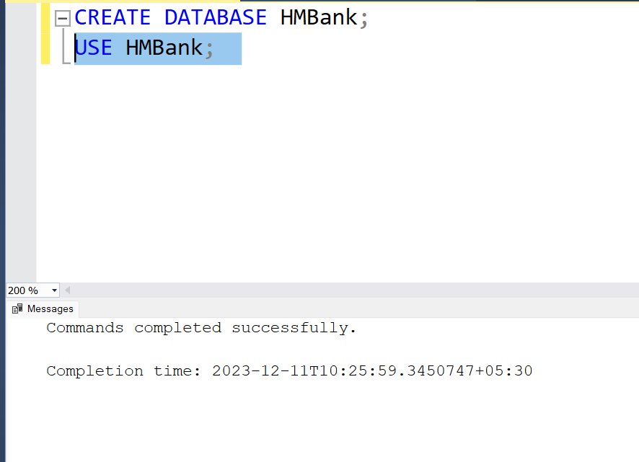

1. **Define the schema for the Customers, Accounts, and Transactions tables based on the provided schema.**

**QUERY:**

CREATE TABLE Customers ( customer_id INT PRIMARY KEY, full_name VARCHAR(100), DOB DATE,

contact_info VARCHAR(255),

address VARCHAR(255)

);

CREATE TABLE Accounts ( account_id INT PRIMARY KEY,

customer_id INT, full_name VARCHAR(100), account_type VARCHAR(20), balance DECIMAL(10, 2), DOB DATE,

contact_info VARCHAR(255), address VARCHAR(255),

FOREIGN KEY (customer_id) REFERENCES Customers(customer_id)

);

CREATE TABLE Transactions ( transaction_id INT PRIMARY KEY,

account_id INT, full_name VARCHAR(100), transaction_type VARCHAR(20), amount DECIMAL(10, 2), transaction_date DATE, account_type VARCHAR(20), balance DECIMAL(10, 2), DOB DATE, contact_info VARCHAR(255), address VARCHAR(255),

FOREIGN KEY (account_id) REFERENCES Accounts(account_id)

);

1. **Create an ERD (Entity Relationship Diagram) for the database.**

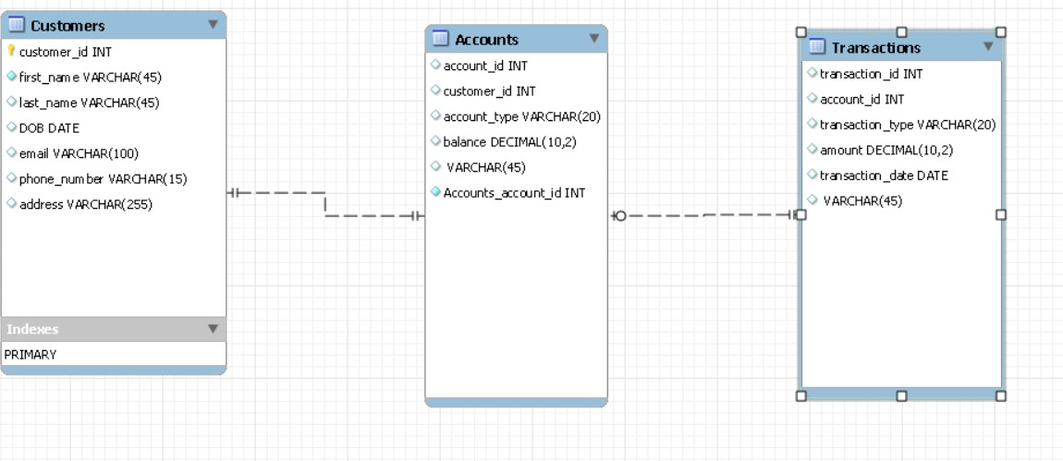

1. **Create appropriate Primary Key and Foreign Key constraints for referential integrity.**

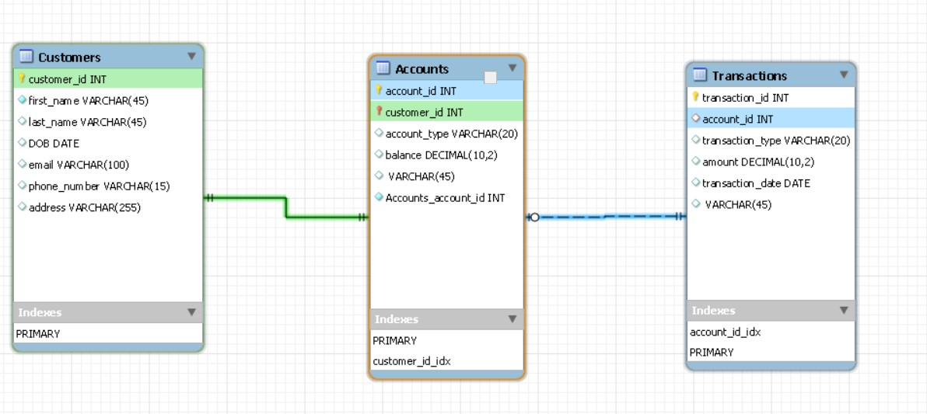

**Task: Data Definition Language (DDL):**

**1. Write SQL scripts to create the mentioned tables with appropriate data types, constraints, and relationships.**

* **Customers**
* **Accounts**
* **Transactions**

**Query-**

-- Customers Table CREATE TABLE Customers ( customer_id INT PRIMARY KEY, first_name VARCHAR(50), last_name VARCHAR(50), DOB DATE, email VARCHAR(100), phone_number VARCHAR(15),

address VARCHAR(255)

);

-- Accounts Table CREATE TABLE Accounts ( account_id INT PRIMARY KEY,

customer_id INT, account_type VARCHAR(20), balance DECIMAL(10, 2),

FOREIGN KEY (customer_id) REFERENCES Customers(customer_id)

);

-- Transactions Table CREATE TABLE Transactions ( transaction_id INT PRIMARY KEY,

account_id INT, transaction_type VARCHAR(20), amount DECIMAL(10, 2), transaction_date DATE,

FOREIGN KEY (account_id) REFERENCES Accounts(account_id)

);

**Task 2: Data Manipulation Language (DML):**

**2. Write SQL queries for the following tasks:**

**1. Write a SQL query to retrieve the name, account type and email of all customers.**

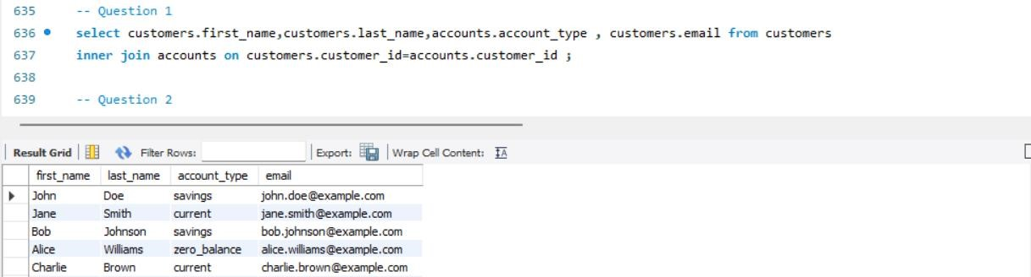

**2.Write a SQL query to list all transaction corresponding customers.**

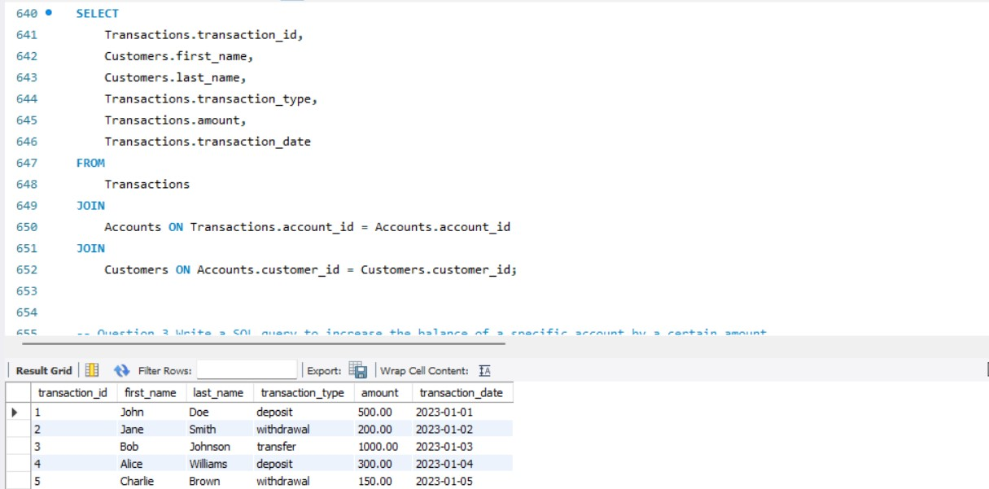

**3.Write a SQL query to increase the balance of a specific account by a certain amount.**

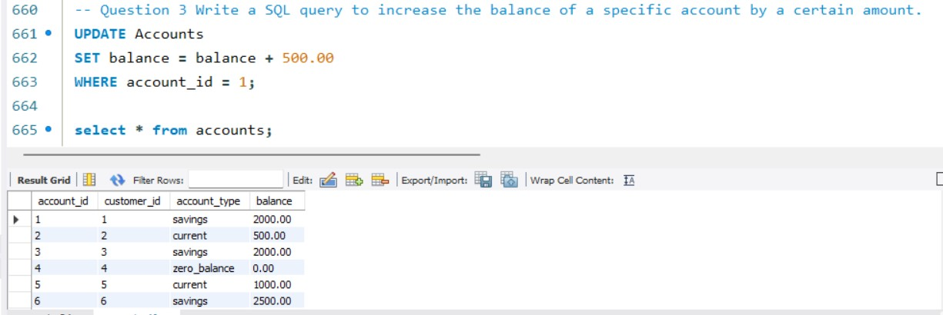

**4.Write a SQL query to Combine first and last names of customers as a full_name.**

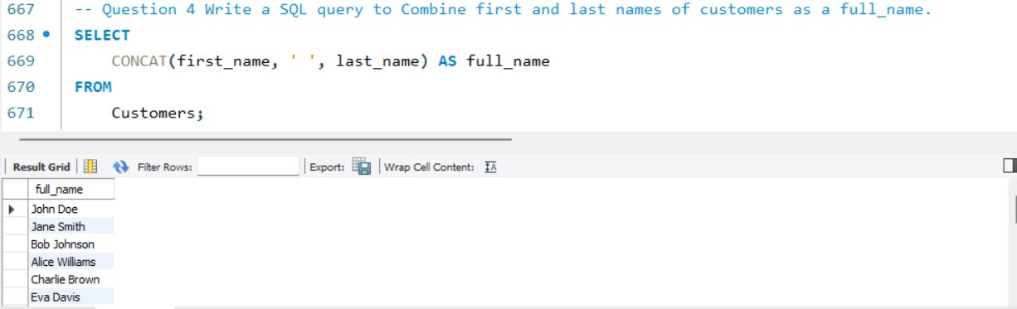

**5.Write a SQL query to remove accounts with a balance of zero where the account type is savings.**

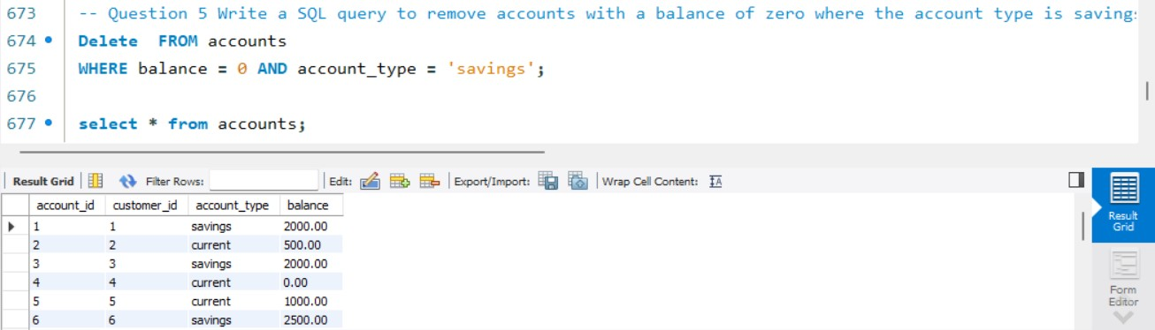

**6.Write a SQL query to Find customers living in a specific city.**

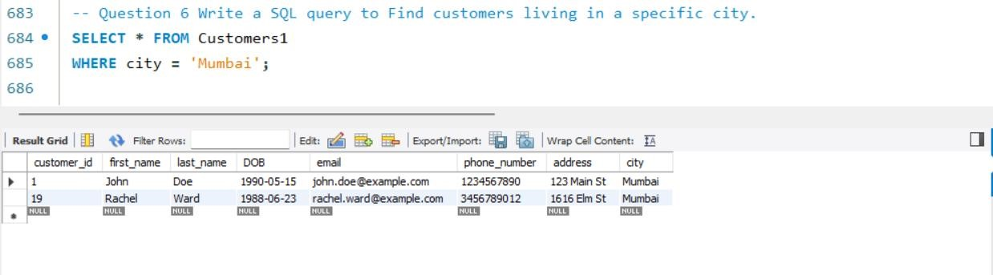

**7: Write a SQL query to Get the account balance for a specific account.**

**Query:**

SELECT balance FROM Accounts WHERE account_id = 102

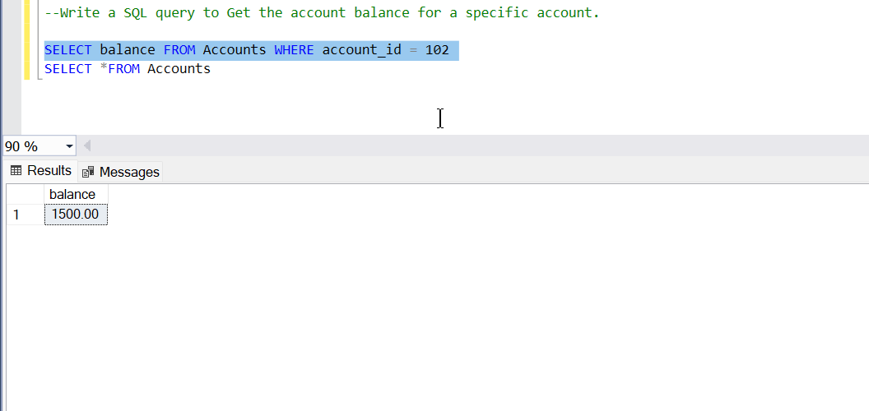SELECT *FROM Accounts

1. **Write a SQL query to List all current accounts with a balance greater than $1,000.**

1. **Write a SQL query to Retrieve all transactions for a specific account.**

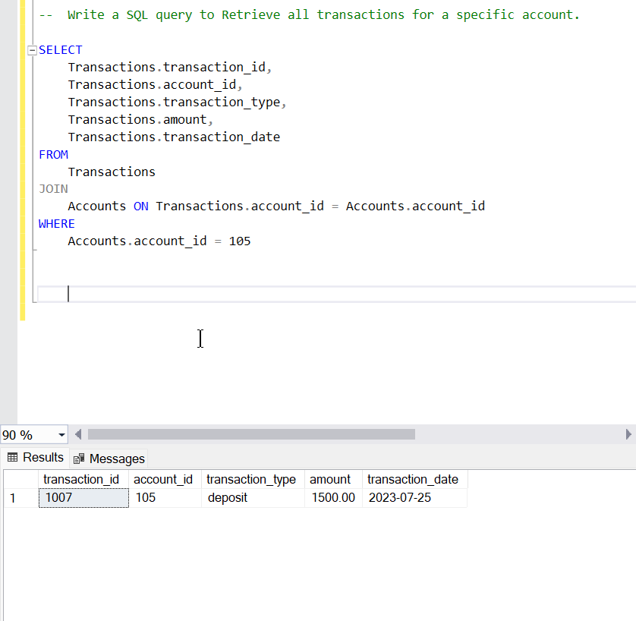

1. **Write a SQL query to Calculate the interest accrued on savings accounts based on a given interest rate 5 percent.**A screenshot of a computer

   Description automatically generated

1. **Write a SQL query to Identify accounts where the balance is less than a specified overdraft limit.**

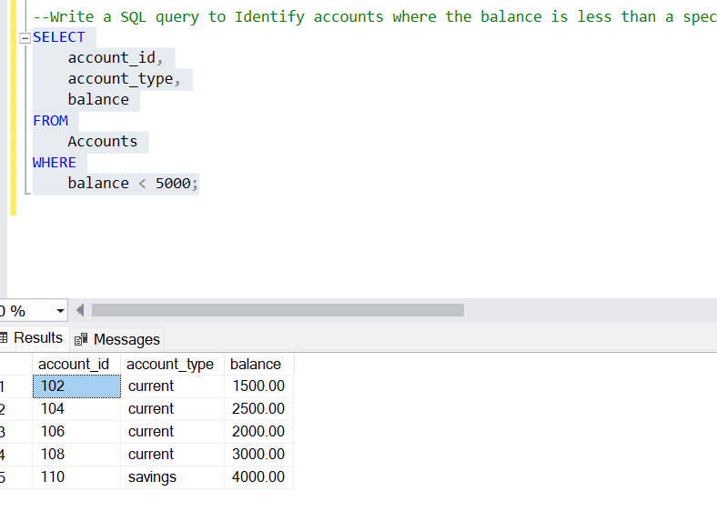

**Task 3: Aggregate functions, GroupBy and Joins:**

1. **Write a SQL query to Find the average account balance for all customers.**

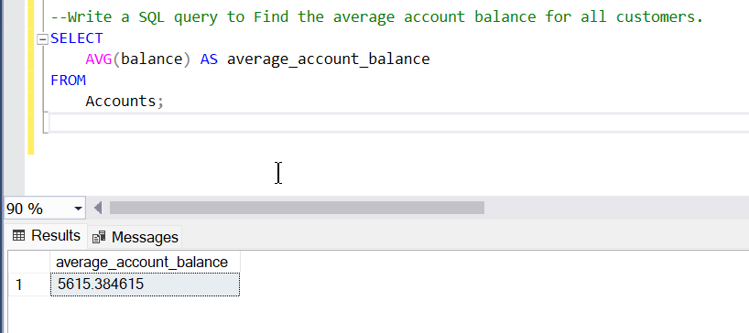

1. **Write a SQL query to Retrieve the top 10 highest account balances.**

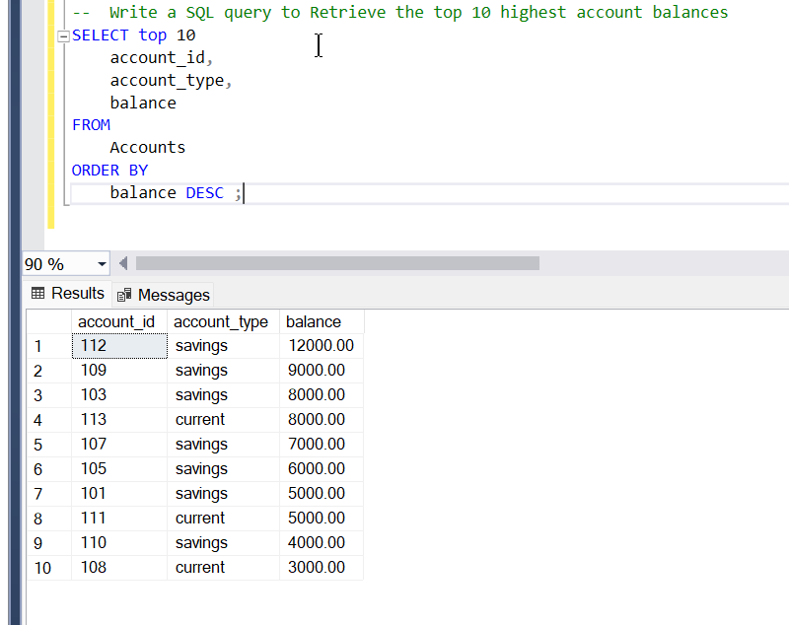

1. **Write a SQL query to Calculate Total Deposits for All Customers on a specific date.**

**4. Write a SQL query to Find the Oldest and Newest Customers.**

1. **Find the oldest customer.**
2. A screenshot of a computer

   Description automatically generated**Find the newest customer.**

**5.Write a SQL query to Retrieve transaction details along with the account type.** **Query-**

**6.Write a SQL query to Get a list of customers along with their account details.**

**7.Write a SQL query to Retrieve transaction details along with customer information for a specific account.**

**8.Write a SQL query to Identify customers who have more than one account.**

**9.Write a SQL query to Calculate the difference in transaction amounts between deposits and withdrawals.**

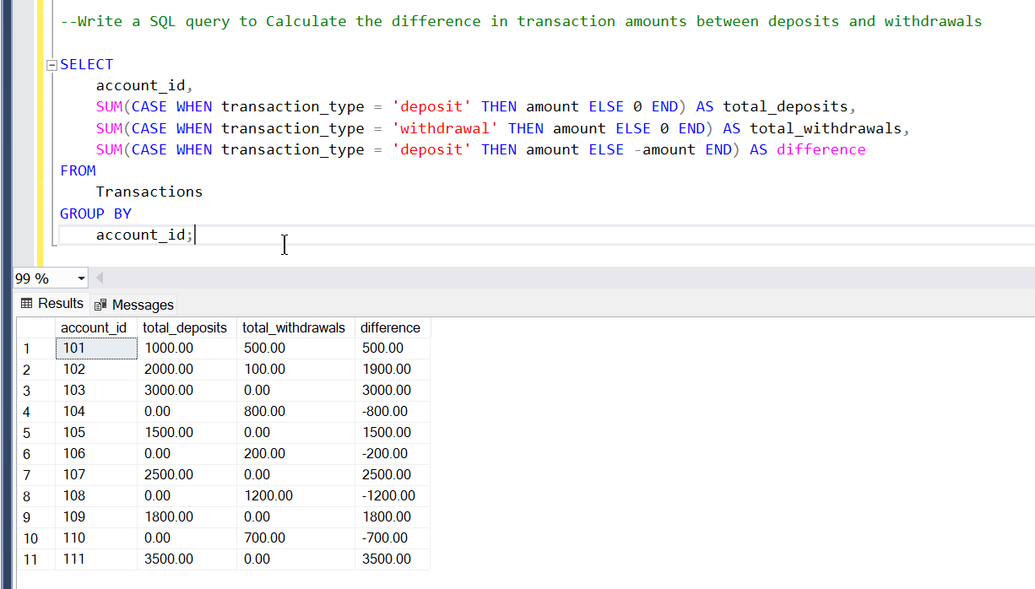

**10.Write a SQL query to Calculate the average daily balance for each account over a specified period.**

1. **Calculate the total balance for each account type.**

1. **Identify accounts with the highest number of transactions ordered by descending**

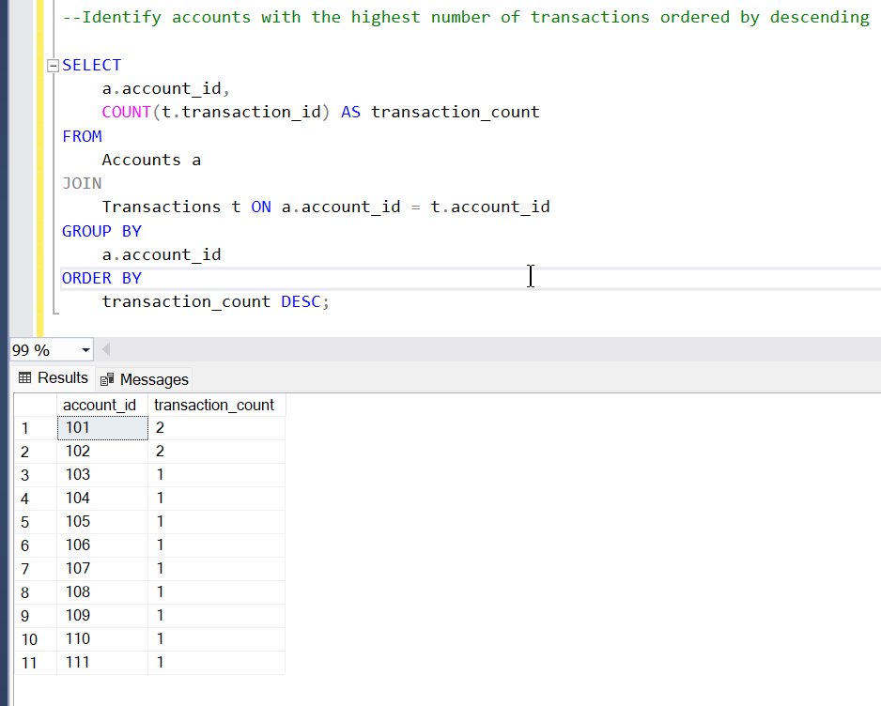

1. **List customers with high aggregate account balances, along with their account types.**

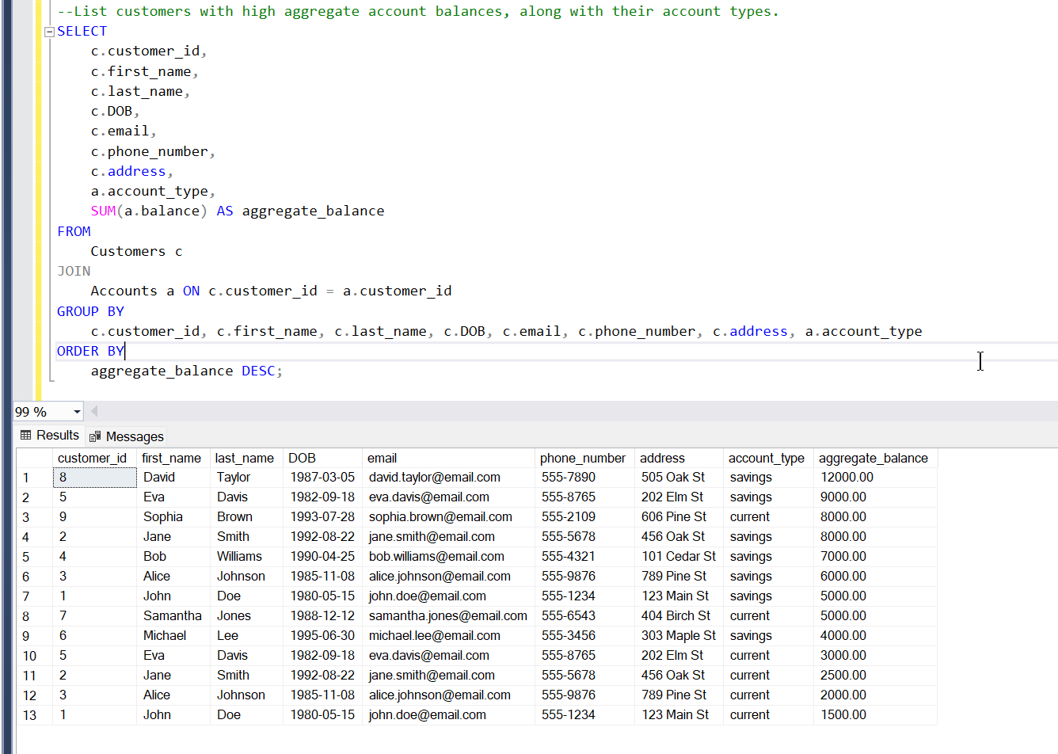

1. A screenshot of a computer

   Description automatically generated**Identify and list duplicate transactions based on transaction amount, date, and account.**

**Task 4: Subquery**

1. **Retrieve the customer(s) with the highest account balance.**

1. **Calculate the average account balance for customers who have more than one account.**

1. **Retrieve accounts with transactions whose amounts exceed the average transaction amount.**

1. **Identify customers who have no recorded transactions.**

**5.Calculate the total balance of accounts with no recorded transactions**

**6.Retrieve transactions for accounts with the lowest balance**

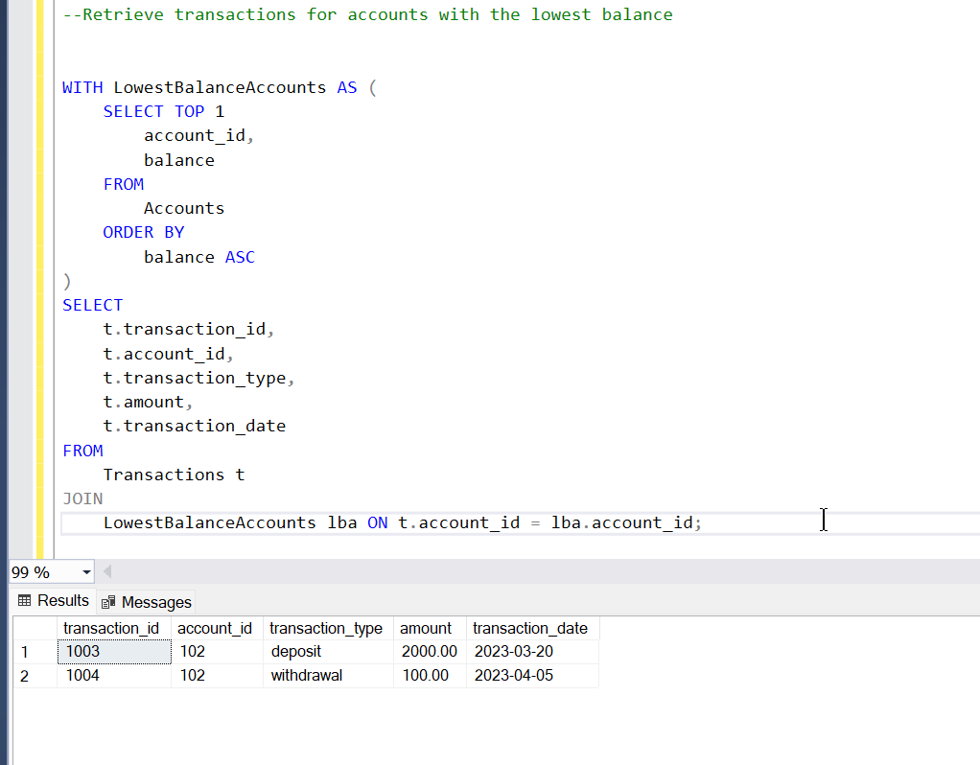**QUERY:**

**7.Identify customers who have accounts of multiple types**

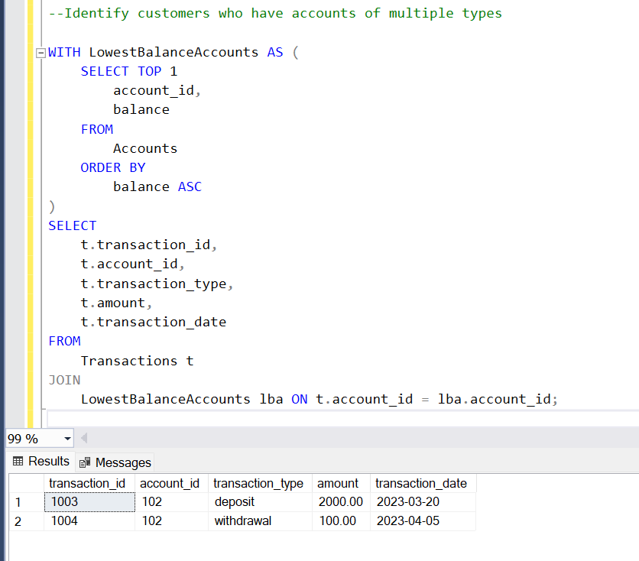**QUERY:**

**8.Calculate the percentage of each account type out of the total number of accounts**

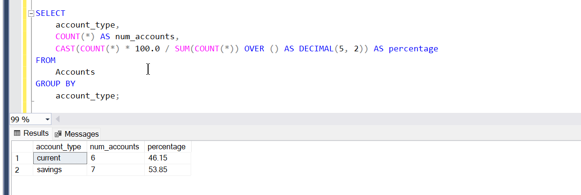

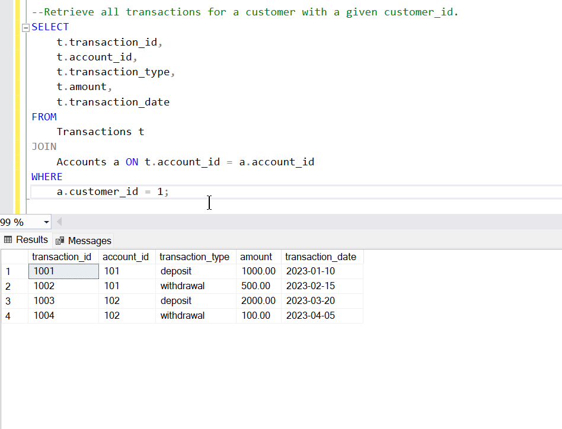**9.Retrieve all transactions for a customer with a given customer_id.**

**10.Calculate the total balance for each account type, including a subquery within the SELECT clause.**

